|  |
| --- |
| **Argentis Consulting** |
| **Apparel & Footwear** |
| DTW - Data Migration of Model POM |



**www.sapapparel.com**

Contents

1 INTRODUCTION 3

2 TEMPLATES 3

2.1 Templates related to Model POM 3

2.1.1 Template: ARGNS_MODELPOM - ARGNS_MODELPOM 3

3 DATA IMPORT PROCESS 4

3.1 Excel Preparation for Model POM 4

4 CSV files import trough DTW –Model POM 5

# INTRODUCTION

This document contains the necessary information to prepare and execute data migration for Model POM using the DTW tool.

# TEMPLATES

## Templates related to Model POM

To import data related to Model POM the following Excel templates need to be completed:

1. ARGNS_MODELPOM - ARGNS_MODELPOM

### Template: ARGNS_MODELPOM - ARGNS_MODELPOM

This is the template that will hold the general information for each Model POM.

The relevant fields in this template are:

1. ParentKey: This is the SAP internal code defined in the code field of the ARGNS_MODEL - ARGNS_MODEL

2. LineNum: Leave blank. This field is automatically completed by DTW during the import process.

3. Code: This is the SAP internal code defined in the code field of the ARGNS_MODEL - ARGNS_MODEL template. Same as ParentKey

4. U_POM:  This is POM code defined in the U_ARGNS_POMS - U_ARGNS_POMS

5. U_Desc:  This is POM description defined in the U_ARGNS_POMS - U_ARGNS_POMS

6. U_SizeCode: Size code belogs to the scale code defined in the ARGNS_POMTEMPLATE - ARGNS_POMTEMPLATE

7. U_Value: Measurement value defined in the ARGNS_POMTEMPLATE - ARGNS_POMTEMPLNS

8. U_TolPosit: Positive tolerance defined in the ARGNS_POMTEMPLATE - ARGNS_POMTEMPLNS

9. U_TolNeg: Negetive tolerance defined in the ARGNS_POMTEMPLATE - ARGNS_POMTEMPLNS

10. U_QAPoint: ‘Y’ to select QA point ‘N’ to deselect QA point defined in the ARGNS_POMTEMPLATE - ARGNS_POMTEMPLNS

11. U_SclPom: Scale code define in the ARGNS_MODEL - ARGNS_MODEL

12. U_PomCode: POM code defined in the ARGNS_POMTEMPLATE - ARGNS_POMTEMPLATE

# DATA IMPORT PROCESS

## Excel Preparation for Model POM

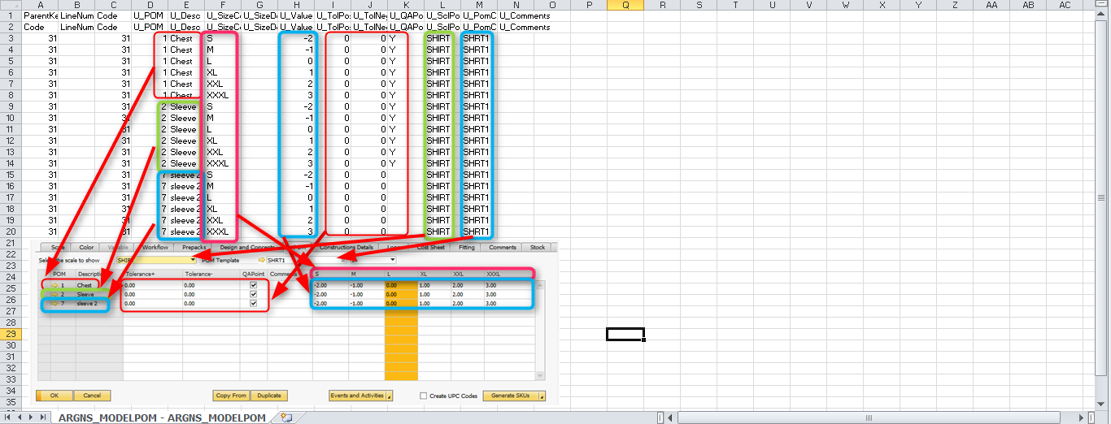

# CSV files import trough DTW –Model POM

1. Click on the “Import” button to start the Data import wizard

2. Select master data as the data type for importing Model POM

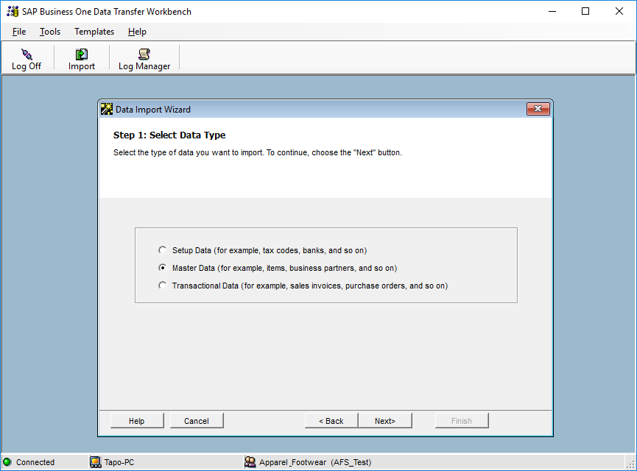

3. Select Add new data and update existing data as the operation type.

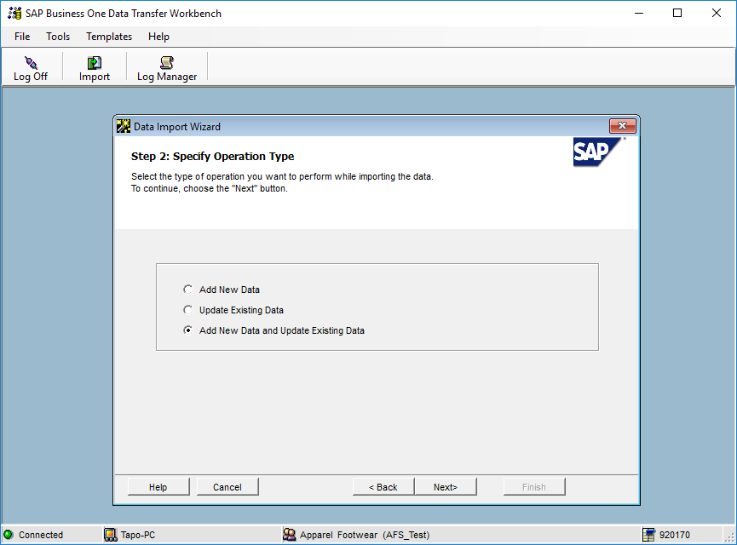

4. Search and select the UDO_ARGNS_MODEL object under the following path: User Defined

Data > Object (UDO) > UDO_ARGNS_MODEL

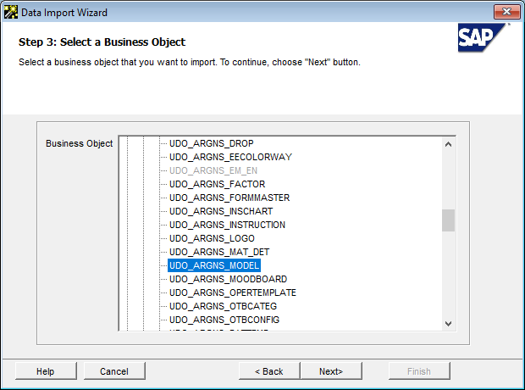

5. Select the templates corresponding to each operation template object.

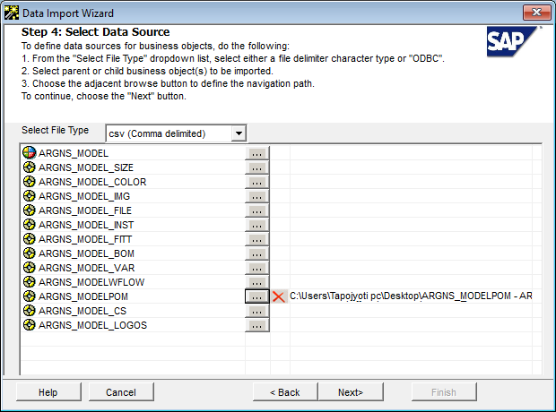

6. Map object fields. This is a confirmation screen for the data mapping.

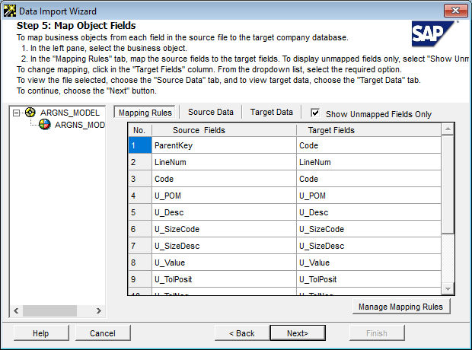

7. Define error handling. It is usually recommended to select the last option to prevent from processing the entire file if a certain number of errors are found. In this step it is usually recommended to run the simulation process (by clicking the Run Simulation button) to get a preview of the data import result.

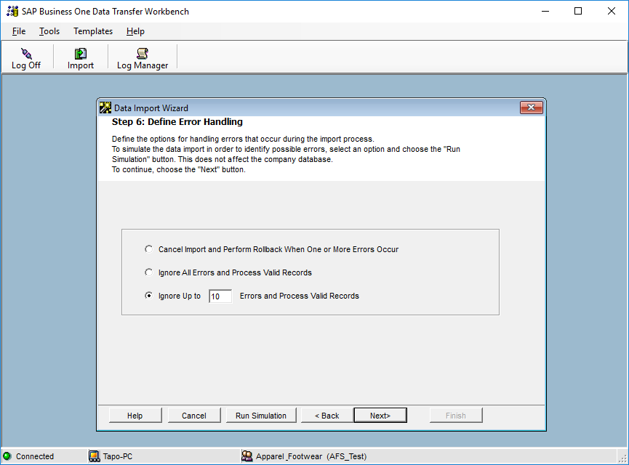

8. Start importing data. If no errors were found in the simulation process, click on the Import button to start the actual data import process. Please not that this does not guarantees that the data imported is accurate and it must be checked within SAP to make sure that everything is being loaded the way it should.



**www.argentisconsulting.com**

**Argentis Consulting** is dedicated to the development, distribution and support of recognized certified solutions for SAP Business One, as an SSP (Software Solution Provider) with a Gold Partner status.

**CONTACT INFORMATION**

|  |  |
| --- | --- |
| **USA**  9744 NW 45th Lane  Doral, FL 33178  info@argentisconsulting.com | **ARGENTINA**  Ávila y Zarate 2048  Cerro de la Rosas, Córdoba,  CP 5009  Córdoba - Argentina  info@argentisconsulting.com |
| **CARIBEAN**  City View Plaza – Suite 301  48 Road 165  Guaynabo, PR. 00968  Puerto Rico  caribe@argentisconsulting.com | **SPAIN**  C/ Juan Bravo N° 3 A 28006  Phone: (+34) 91 123 7263  Madrid - Spain  info@argentisconsulting.com |